Building an AI system using Python

Setting the scene

When we use sensors with the Arduino, a large amount of data is gathered. It is useful to be able to build models which are able to analyse this data. In this project you will learn how to use Python to analyse data. You will then be able to use these skills when analysing devices built using the Arduino.

Success criteria

- Understand how to install libraries within Python
- Understand how to use various data analysis libraries within Python
- Understand how to train a model
- Understand how to use a trained model to make predictions

Instructions
You are now going to build a model using labelled data to predict a type of Iris plant. This worksheet is based on the use of https://repl.it but any Python interpreter will be fine.
The first step is to create a new project.

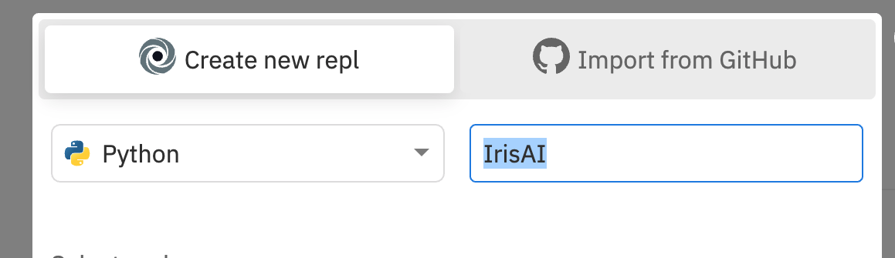
Click on ‘Create new repl’ and give your project a descriptive name. Ensure that you have selected Python as the language.

Then click on ‘Create rpl’.


Importing your data file
You are now going to import the iris.csv file. Click on the three dots at the side of files and then upload file.

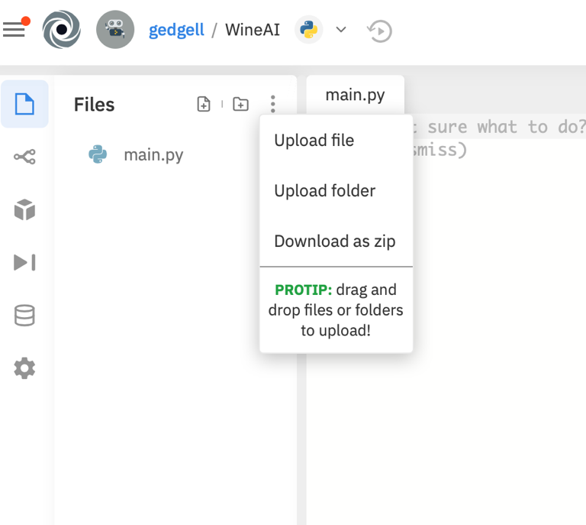
Upload the Iris.csv file.

Investigating the CSV file

You are now going to write a program to explore the contents of the CSV file. We are going to import a number of libraries into Python which we can use to analyse the data for us. These libraries work in the same way as libraries within the Arduino IoT cloud. In Python, we use the import command. We are importing specific elements of the library, so we combine the import command with a from command. For example, we are importing the ‘read_csv’ function from the pandas library. Please note that some IDEs will underline the various libraries if they are not used. As you work through this project, these underlines will be removed as you utilise each function.

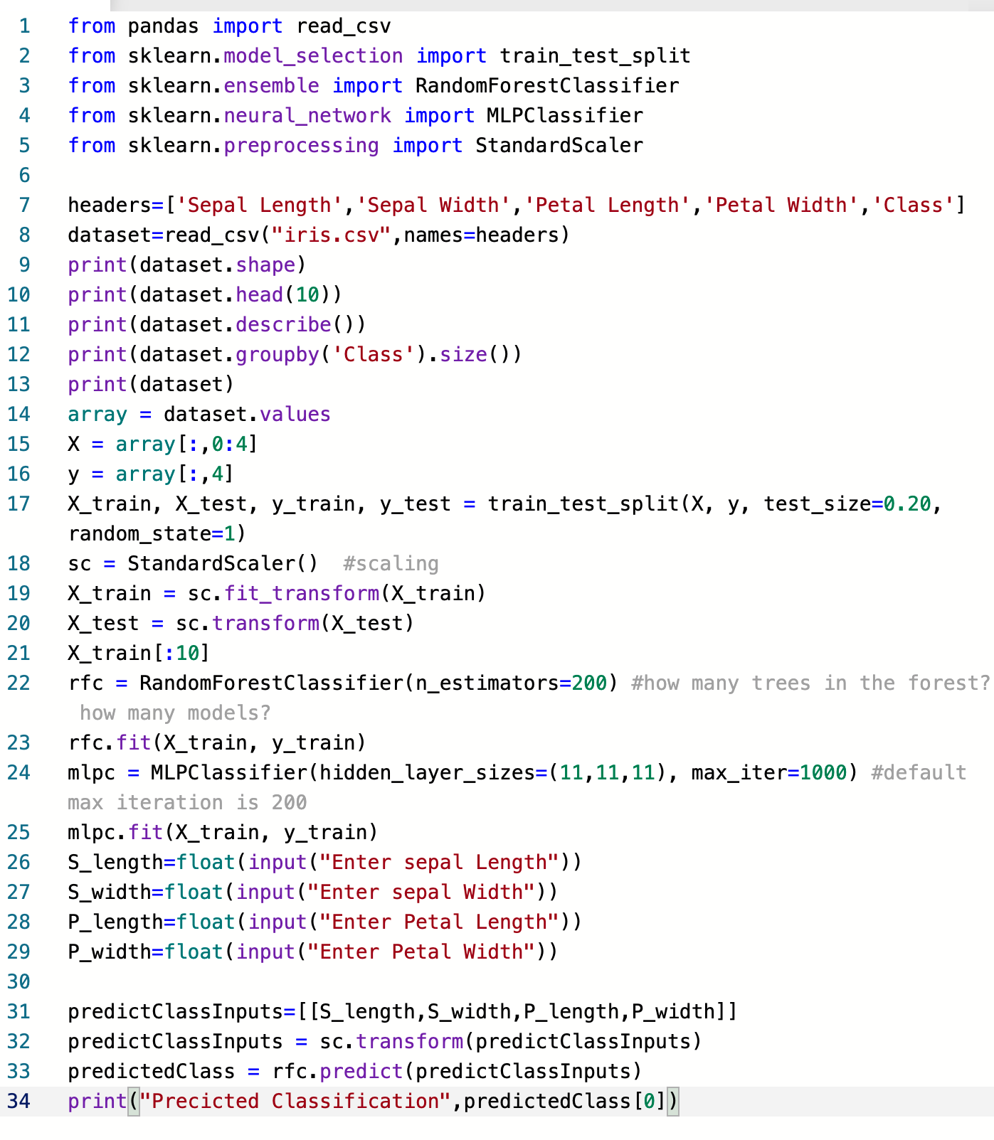
It is now useful to say what each column in the CSV file represents. We can use a list with the headers in it. The first item in the list is the heading for the first column in the CSV file. We are also going to import a function from pandas to read the file.
Before you enter the code above try to predict the purpose of lines 6 to 7 and what the output will be from line 9. It may help you to look at the content of the iris.csv file in either a text editor or spreadsheet. Write your prediction below.

Once you have predicted what will happen, enter and run the code. Were you correct in your predictions?

From looking at the CSV file you will see that it contains the raw data. There are no headings in the document, so it isn’t clear what each of the columns represents. Line 6 creates a list called headers with each element of the list being the header for the corresponding column.

Line 8 is going to read in the contents of the csv file and also the list and set each item in the list to being the ‘name’ of that particular column. The data will then be stored as ‘dataset’.

Line 9 outputs the shape of the dataset; i.e. the number of fields and records which are included.

From the output, you can see that there are 150 records each containing 5 fields.
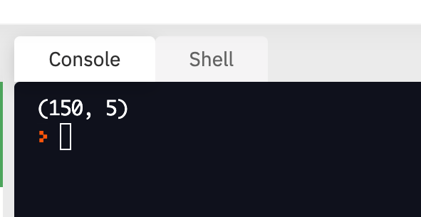

You are now to add a further line to your code: print(dataset.head(10)). What do you think this will output?

You should now add the line of code to your program and run it. As you can see it outputs the first 10 records of the dataset. You can also now see the importance of adding the header row which describes the content of each column.

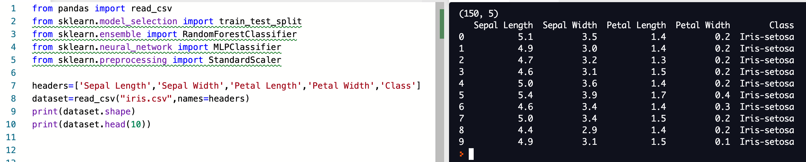

We are now going to add a further line to show a summary of each of the columns. As you can see this will show you a summary of each of the columns of data including the mean, standard deviation, min and max.

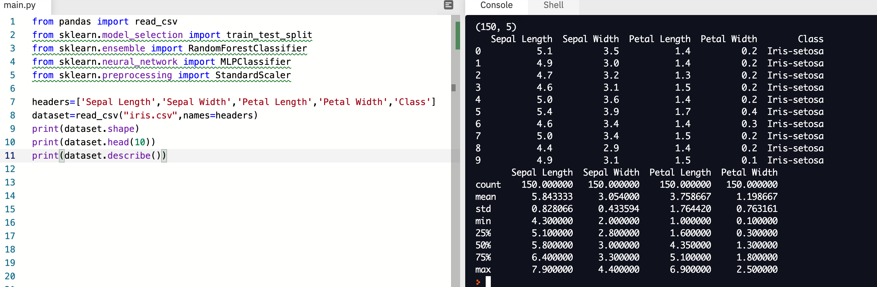

You are now going to add the line: print(dataset.groupby('Class').size()) to your code. Can you predict the purpose of this line of code?

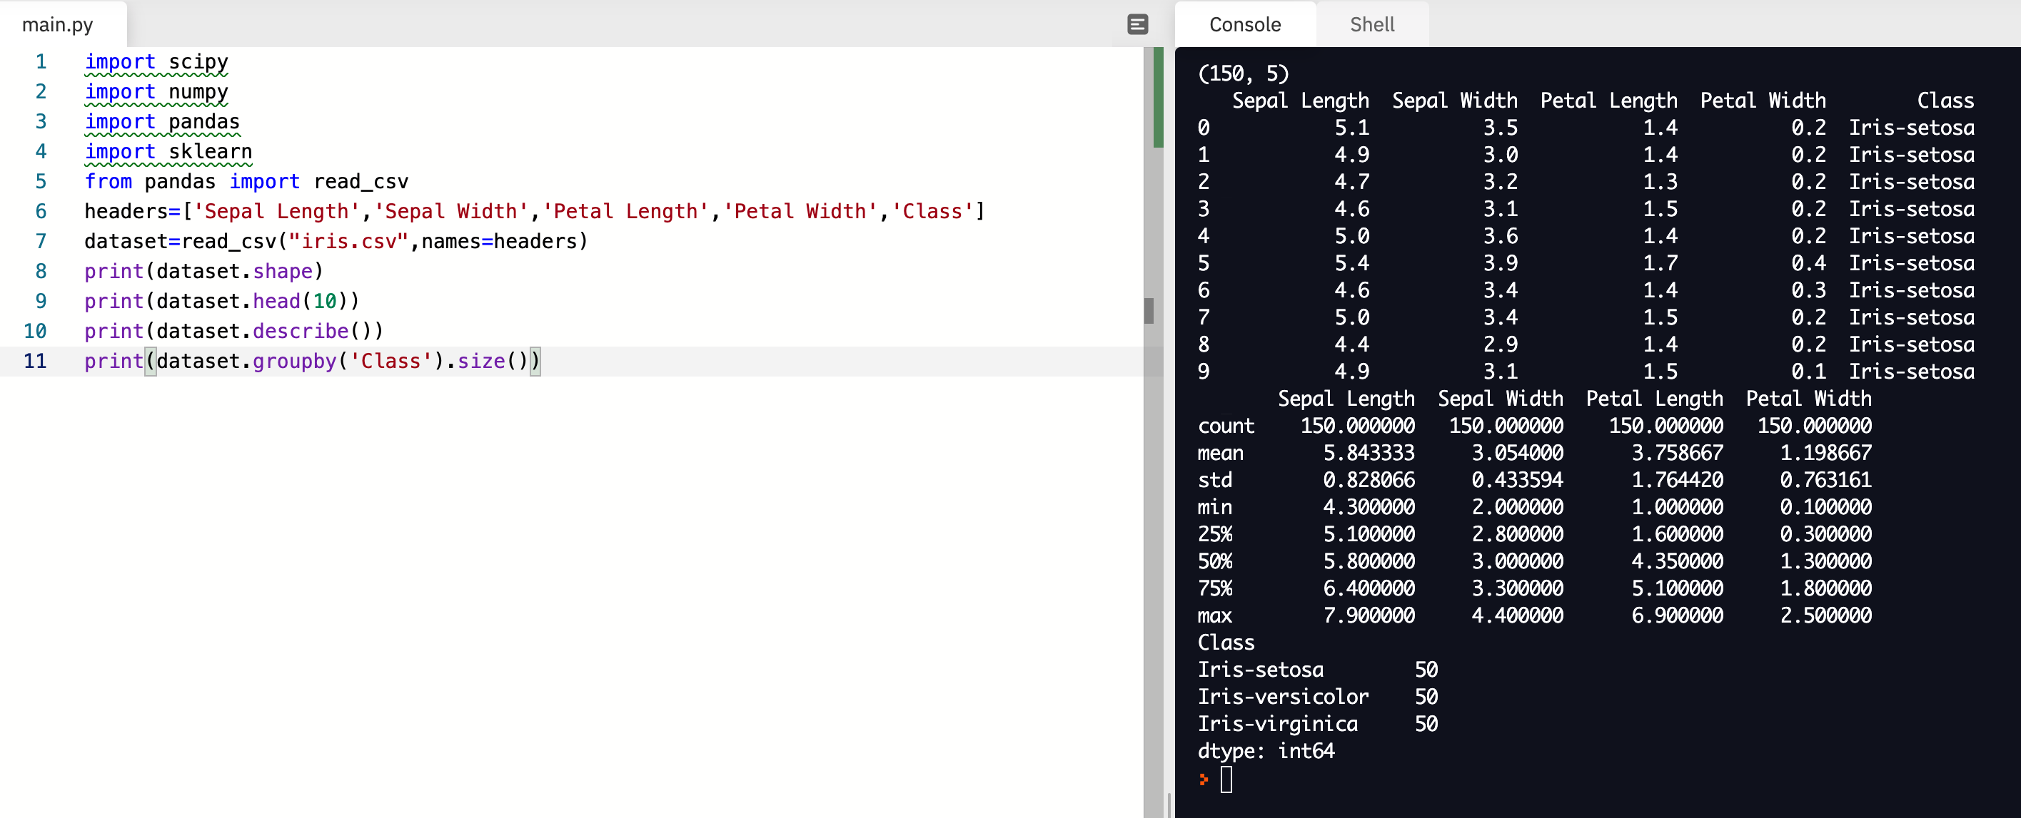
This code can be used to summarise individual columns in the dataset. Using the size command, we can see how many items fit into each classification in the ‘Class’ column. The classification relates to the type of Iris that has been identified from the various characteristics that are stated.

Pro-tip
The class of Iris should not be confused with a Class in programming which is a blueprint for an object. The class of Iris can be determined by examining the sepal length, sepal width, petal length and petal width.

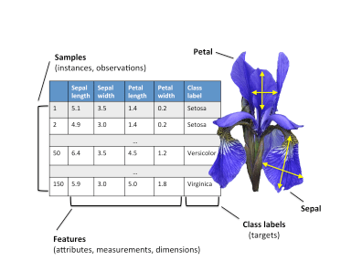
Image source: https://i1.wp.com/sefiks.com/wp-content/uploads/2018/10/iris-dataset-description.png?resize=396%2C297&ssl=1

Creating an AI model to predict the classification of Iris

Now that we have investigated our dataset, we are going to start to build our AI model. We are going to try and establish a relationship between each of the variables in order to determine the class of Iris. As the data which we have contains the label ‘Class’, this is going to use supervised learning.
To create our model, we are going to use several functions within the sklearn library. Insert the new lines of code below after line 5 in your code. It is good practice to import all the different libraries that you are going to use prior to writing your own code. This aids maintainability.
We are now going to take the data which is held in the variable dataset and extract the values. We are then going to create two lists from those values called X and y.
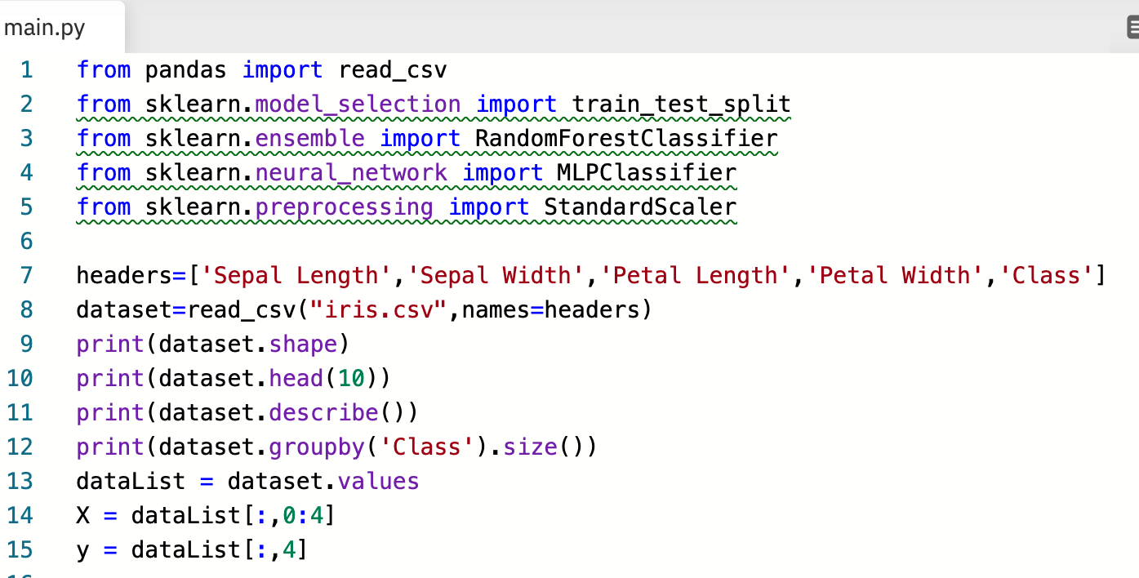

Can you predict what data will be held in X and y?

Add in 2 print statements to identify what is held in X and y. Were your predictions correct?

X takes each row in the dataList and extracts the items in positions 0, 1, 2 and 3. This is the data excluding the classification. y takes the dataList and extracts the data that is in position 4 which is the actual classification of the Iris.
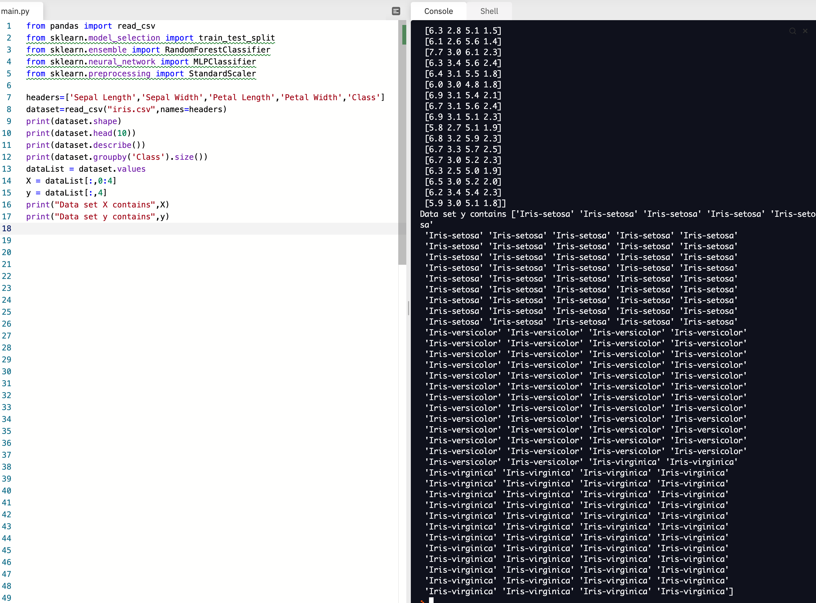
Now that we have checked what is stored in X and y, we are going to hash out those print statements. The next step is to create our test and training data. To help us with this, we are going to use the train_test_split function from the sklearn library.
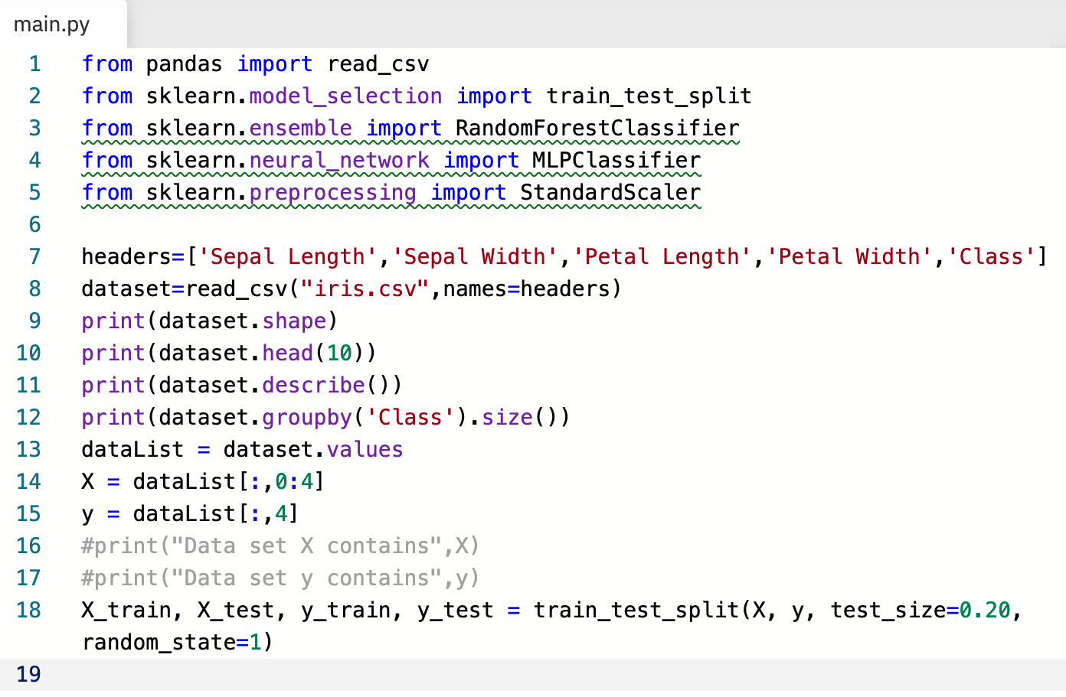

In Line 18 we are going to generate four variables, X_train, X_test, y_train and y_test. The X items will include the sepal length, sepal width, petal length and petal width. The y items will include the corresponding class of Iris for each of those measurements. To generate that data we are going to pass in X and y into the train_test_split function. The test_size in the example above has been set to 20% with 80% of the data being used to train the model. The random_state controls the shuffling of the data before splitting it into training and testing data.
Our next 3 lines of code are used to standardise the dataset. This helps to ensure that individual features represent normally distributed data. The transform command performs the actual standardisation by centring and scaling.
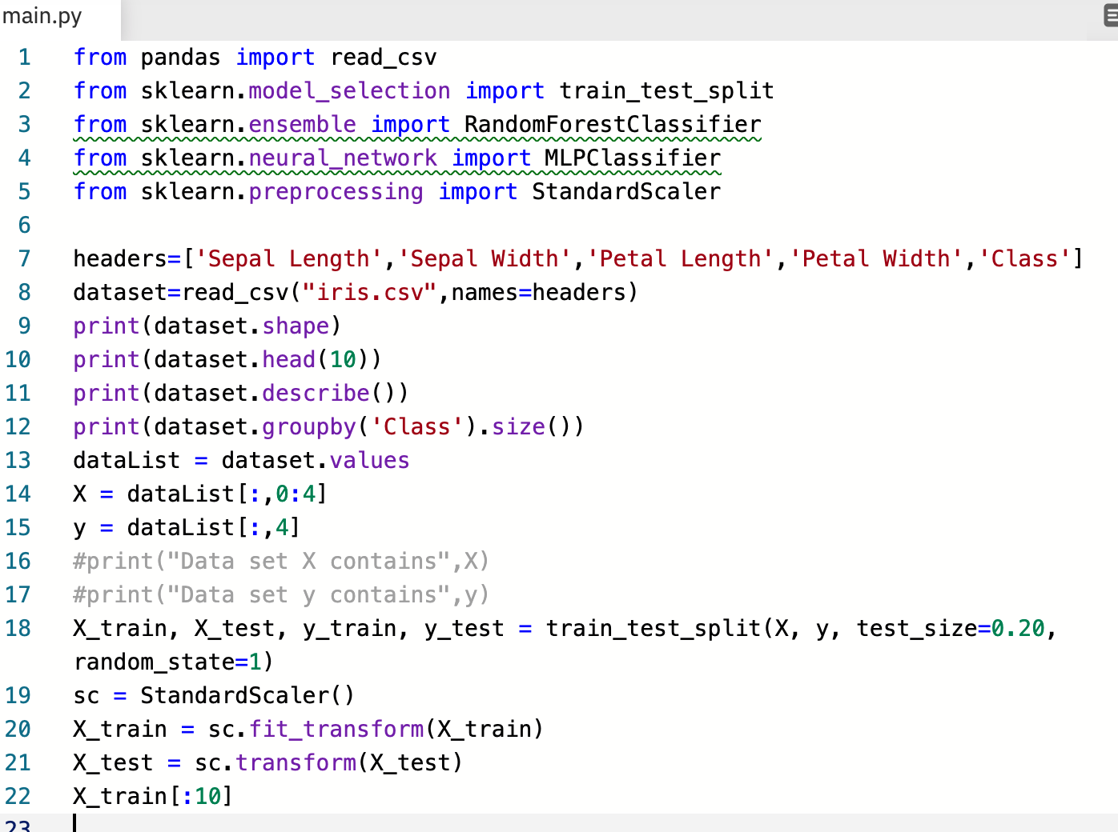

To perform the actual learning, we are going to use the RandomForestClassifier which is found within the sklearn library. This will use various decision tree classifiers on different sub-samples of our dataset. n_estimators represents the number of trees in the forest which is used to determine the number of models to be created. We have set our example to being 200. The rfc.fit then creates a forest of trees using our X_train and y_train datasets.

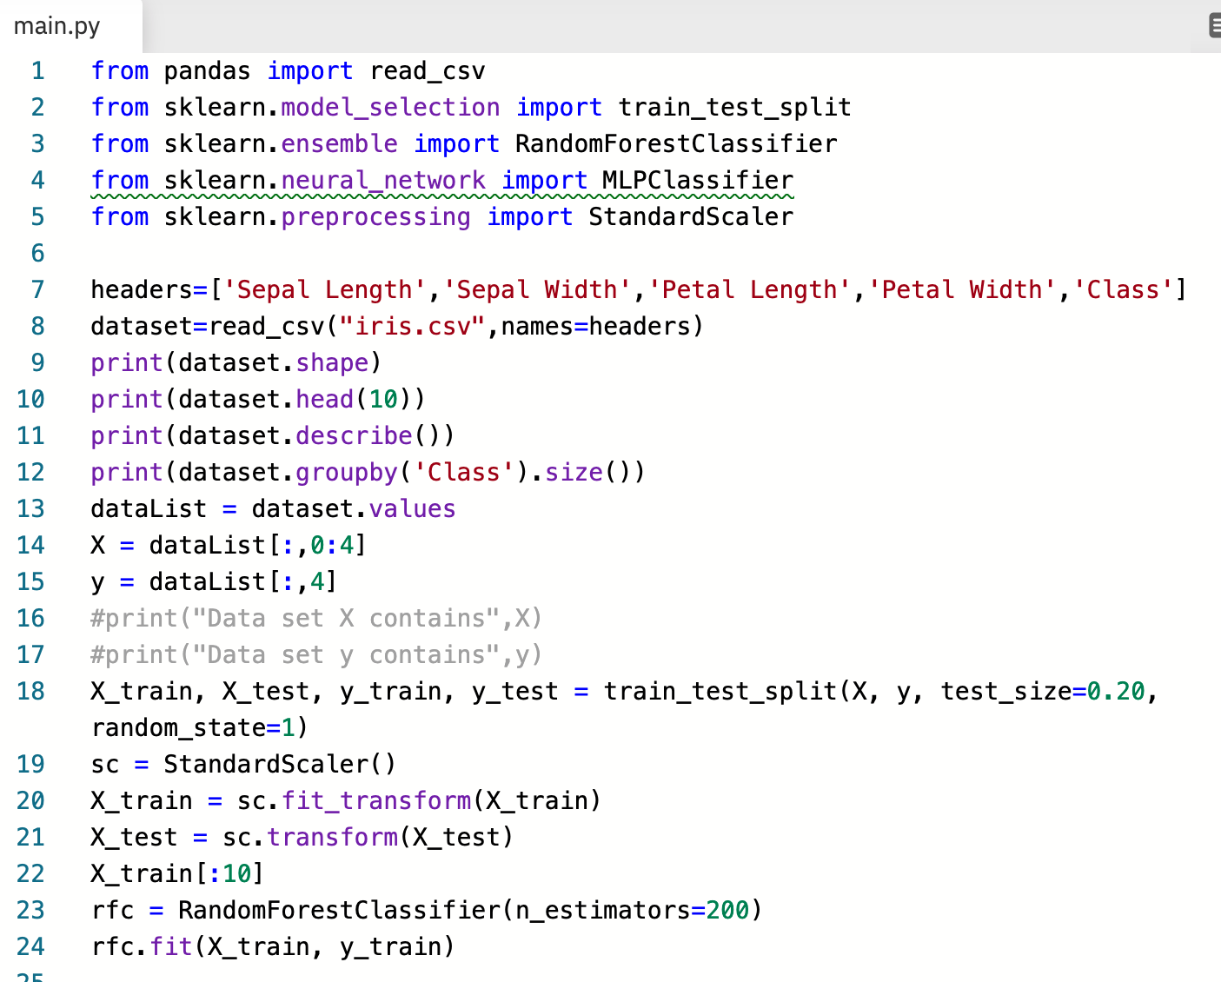

Using the Model to make predictions

You should now create four input statements which allows the sepal length, sepal width, petal length and petal width to be entered. Each should be a float data type. Each of these inputs should then be passed into our model. The model will then process the data and predict what the classification will be.

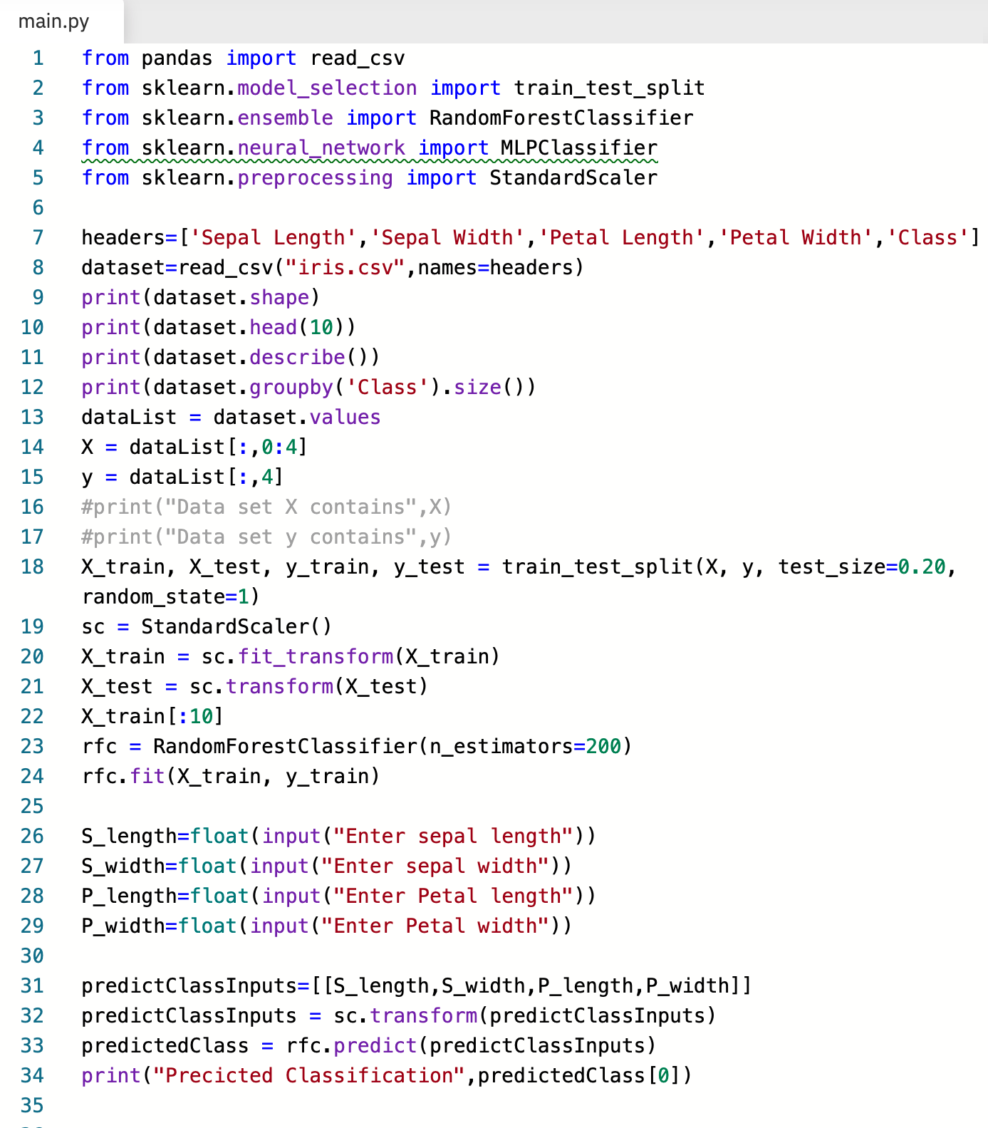

Test your model with a set of inputs from your test data.
Sepal length: 5.1
Sepal width: 3.5
Petal length: 1.4
Petal width: 0.2
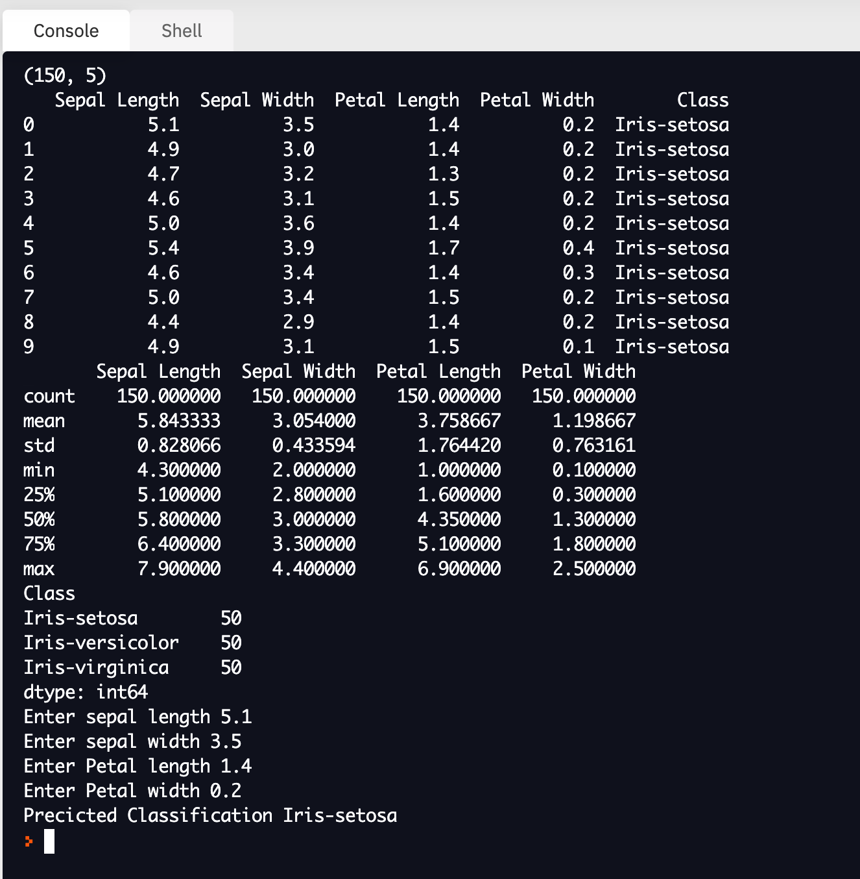
As can be seen above, our model has correctly identified that the classification is an Iris-setosa.

Using your new model with data gathered from the IoT Cloud

Now that you have a functioning model, why not use it to help to analyse data gathered for other IoT projects? If you have built the device which analyses swings of a baseball bat you could use the gathered data and then add a label to rate the quality of the hit. This would then act as the label in the same way as the Iris classification; thus enabling supervised learning to take place. Further data could then be analysed by your model to determine the success of a hit based upon the measured characteristics.

Stretch tasks

Try to expand your model to the MLPC classifier which uses a neural network. You have already imported the necessary library. Information on how to use this classifier can be found by visiting: https://scikit-learn.org/stable/modules/generated/sklearn.neural_network.MLPClassifier.html.

Final thoughts

You have now learned how to analyse data using Python. These libraries can be used to analyse the data from your Arduino sensors. It isn’t always obvious what the relationships are between different measurements; the use of AI can help to identify these links and then make forecasts.

